1. Introduction:

1.1 Overview:

Wholesale or distributing is the sale of goods to retailer to industrial, commercial, institutional or other professional to other wholesale (wholesale businesses) and related subordinated services. Wholesale is buying goods in bulk quantity, usually directly from the manufacturer or source, at a discounted rate. The retailer then sells the goods to the end consumer at a higher price making a profit.

The consumption and production of marketed food are spatially separated. Production is primarily in rural areas while consumption is mainly in urban areas. In today’s highly competitive business landscape, gaining deep market insights is essential for business to thrive and grow. This project aims to analyze customer spending behavior and identify opportunities for growth by leveraging data analytics and data driven decision-making.

The primary objective of this project is to understand customer spending patterns, preferences, and trends across various dimensions .by conducting a comprehensive analysis, businesses can optimize their marketing strategies, improve product offerings, and enhance customer engagement to drive revenue growth.

1.2 Purpose:

Wholesales are not manufacturers. Their business is distributing the end products.they purchase goods from manufactures in bulk at a discount and sells to retailers. Wholesalers also provide cost saving to retailers when retailers buy in bulk from the wholesaler.

* He buys in bulk quantities from producers and resells them to retailers in small quantities.
* He usually deals in a few types of products.
* He is a vital link between the producer and the retailer.
* He sets up own warehouses to store goods for ready supply.
* He operates in a specific area determined by producers.
* A wholesaler may be an individual or otherwise a firm.
* They also provide financial assistance to the producers/manufacturers.
* They maintain warehouse and god own at different place in the country in facilitate the trade at minimum transportation charges .They sometimes make the grading of goods under their own name or brand name.

2. Problem Definition & design Thinking:

2.1 Empathy map:

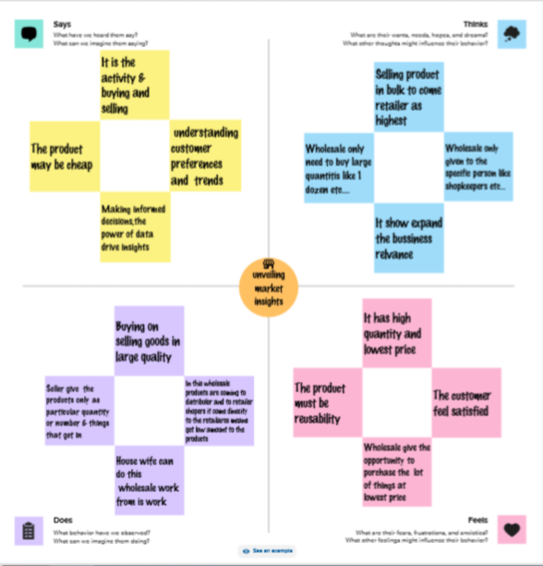

2.2 Ideation & Brainstorming map:

Brainstorming map

## 3. Result:

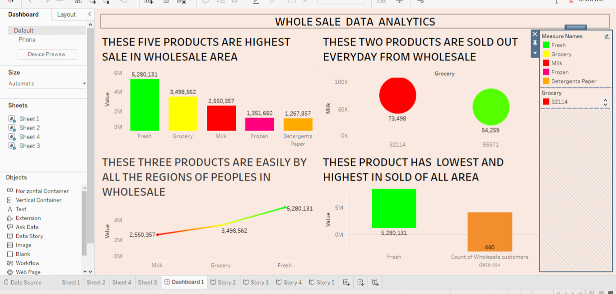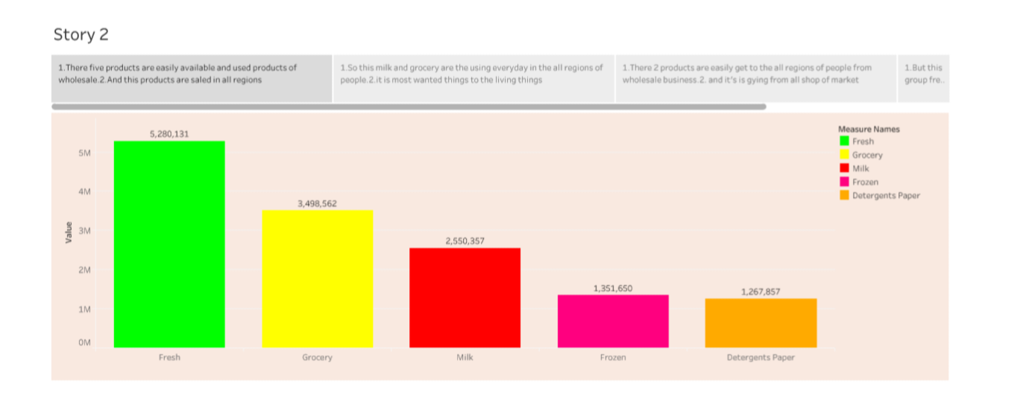

## 4. **Advantage** & **Disadvantages**:

Advantages:

* Increasing sales without increasing the marketing budget
* Building brand value by boosting customer’s life time value
* It boosts your credibility
* Reduce your store’s total operating costs
* Creating your own brand

Disadvantages:

* Beans risks associated with distribution
* Incurs costs of advertising products
* Incur costs of transporting goods to retailers
* Manufacturers will have to break bulk
* Incurs cost of storage.

5. Application:

Produce protection goods are protected from the elements and stored under more hygienic conditions, thus reducing spoilage;

Improved handing operations the market considerably reduces loading and unloading times as well as repeated handling of goods between unloading and display vehicles are also parked and unutilized for shorter periods;

Easier introduction of innovation and new technology the physical concentration of a large group of operators at the same place makes it easier to introduce innovation and to develop improved storage handling and management technology and methods.

6. Conclusion:

The aim of the research was to prove that the construction of the modern wholesale centre in nova sad would lead to an increase in trade in agro- industrial products a replacement for the so called quantitative market .which are considered the informal places of wholesale trade in agro –industrial products . The significance of the wholesale market for agro-industrial products based on the conducted research is considered as an intended approach to the improvement of the development of trade and service activities wholesale markets therefore play a crucial role in the vertical coordination of food markets, equilibrating supply with demand and facilitating .price formation. Their role reduces per unit marketing cocts, promotes stable market for local produce and encourages increased output and productivity.

7. Future scope:

Wholesale is one of the important links in the supply of goods to customers. They buy goods in bulk from the producers and sell them in smaller quantities to retailer .in some cases; they may also sell goods directly to the consumers if the quantity is large enough.

The wholesale distribution business is a important component of the supply chain.almost researched a tipping points during the global pandemic.due to covid 19 customer preferences have shifted to e-**commerce.**

**Thank you!!**